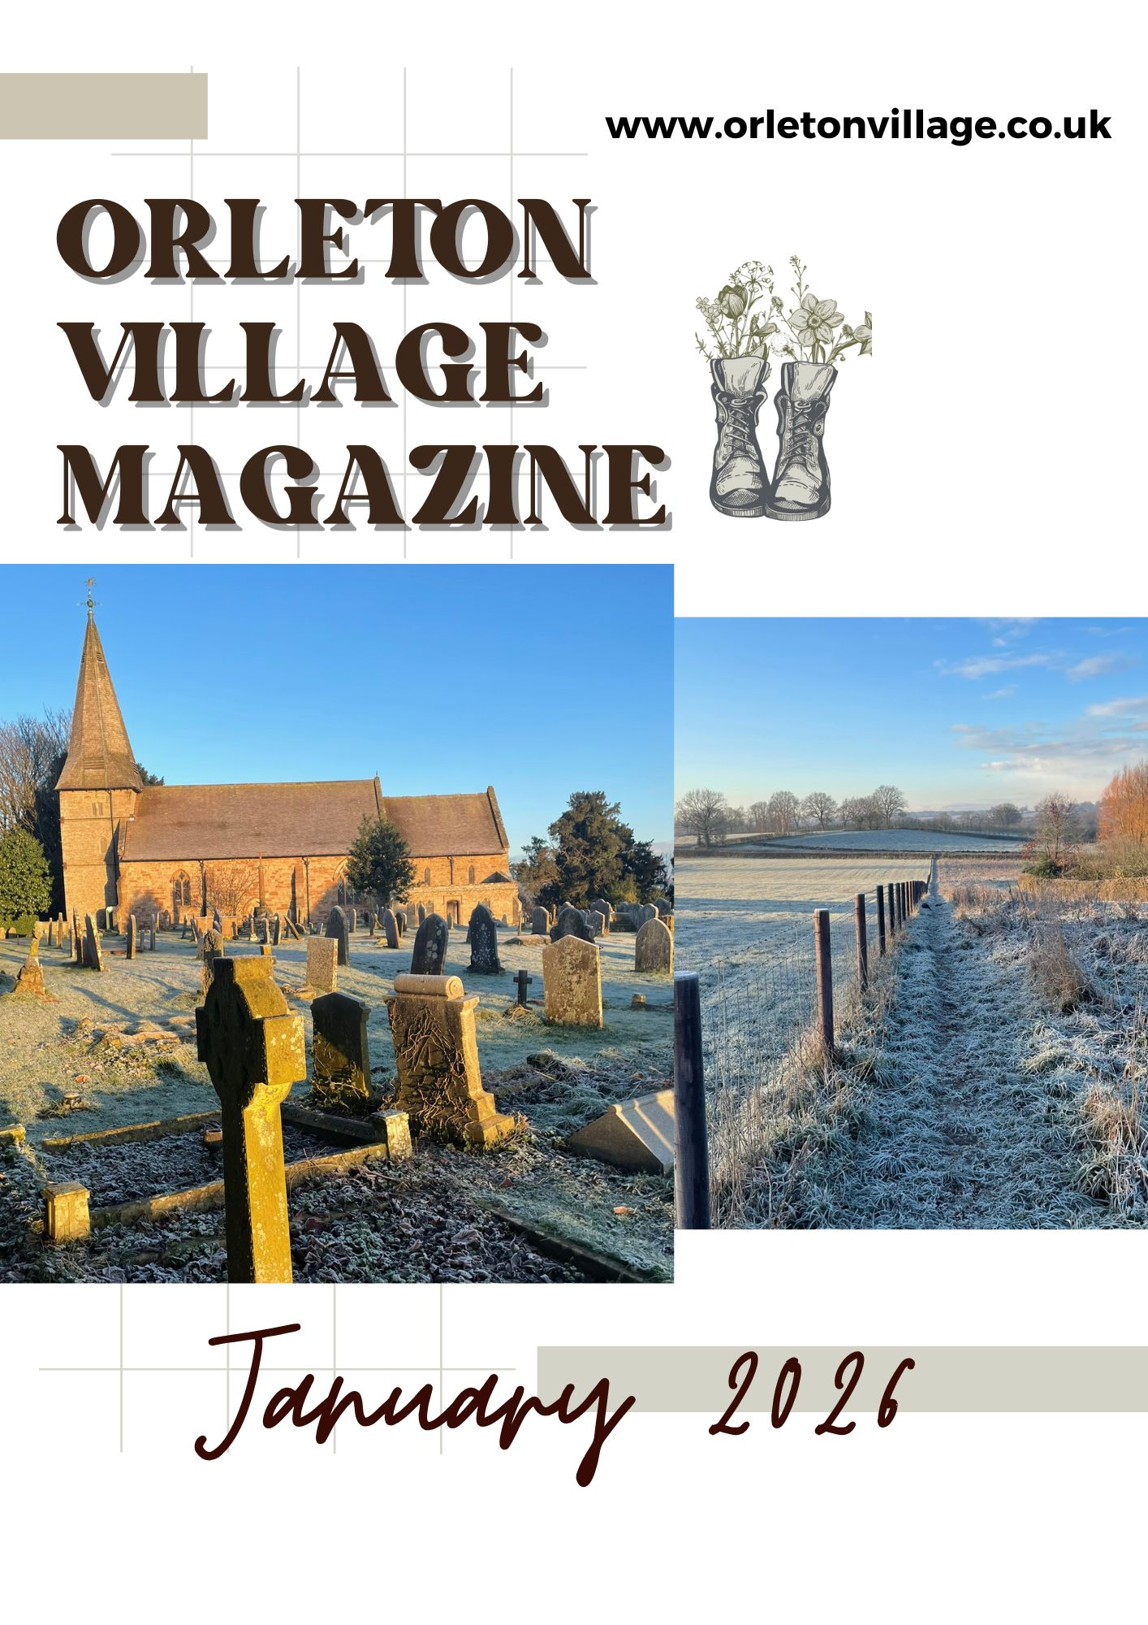

How to be included in

Orleton Village Magazine

This magazine will be published on the first day of each month on the Village Website: *www.orletonvillage.co.uk.* Notification of publication, together with a link, will be given on Nextdoor and Orleton Village Chat (Facebook)

Articles of general interest, club or association reports and advertisements for community events may be included without charge. Commercial advertisements are charged, dependent on size. (Rates available on request from: [orletonmagazine@gmail.com](mailto:orletonmagazine@gmail.com))

Small private sale advertisements may be accepted without charge if space allows

**Orleton Village Hall**

**Ideal venue for family events, parties, weddings, concerts, dances,**

**training courses, drama performance, exhibitions, classes and craft fairs.**

**Large hall (160 seating capacity) with proscenium stage, theatre lighting and sound system, electric piano, video projector and radio mike.**

**Additional small hall (50 capacity)**

**Superb five star rated kitchen, cutlery and crockery. Large car park.Free Wi-Fi**

**Also tables, chairs and marquee available for hire for garden parties**

**For bookings /quotations: bookings@orletonvillage.co.uk**

**Tel 01568 780583**

All content is accepted at the discretion of the editorial team. Articles that are disrespectful or prejudicial will not be accepted.

Copy should be submitted as Word or PDF files. If hard copy is submitted there may be a charge for scanning and input.

All copy must be accompanied by the name, address and telephone number of the author, although this will not be included unless incorporated into the article.

Articles for publication should be emailed to: [orletonmagazine@gmail.com](mailto:orletonmagazine@gmail.com) by the 20th of the month prior to desired publication

**Editorial**

**Orleton Village Hall**

**Ideal venue for family events, parties, weddings, concerts, dances,**

**training courses, drama performance, exhibitions, classes and craft fairs.**

**Large hall (160 seating capacity) with proscenium stage, theatre lighting and sound system, electric piano, video projector and radio mike.**

**Additional small hall (50 capacity)**

**Superb five star rated kitchen, cutlery and crockery. Large car park. Free Wi-Fi**

**Also tables, chairs and marquee available for hire for garden parties**

**For bookings /quotations: bookings@orletonvillage.co.uk**

**Tel 01568 780583**

**May we wish all our readers**

**a very Happy New Year!**

Congratulations to the Stars and Angels Festival. The impressive displays in the Church were submitted by a wide range of local organisations and businesses. A real community effort!

This is only the third edition of our Village Magazine and we are still “feeling our way”.

We have tried to cover all village activities, to let residents, both old and new, know what is going on in our village, to promote our local clubs and societies, and other groups serving our Community. In this we rely on those groups and organisations letting us have the appropriate information for publication. May we thank all those who have contributed to this issue.

If you have content please send it to us. (Details on previous page)

We also welcome your comments and suggestions for improving our magazine

We will be publishing the following content:

* Reports of local activities
* Free adverts for events open to the community.
* Paid adverts from local businesses offering local services
* Free private for sale adverts

The last two categories will be limited as we do not want to swamp the magazine with advertising. Our production costs are low so only a few select adverts from local services or sale items will be accepted for publication.

**Orleton Evergreens**



**Folk at the Boot**

Not just folk but all genres

of music

Performers always welcome



It's always 2nd Thursday of the month at 8.00pm

The Evergreens Committee wishes all past, present and future members and visitors a happy, healthy and peace-filled new year.

Fifty of us sat down to our Christmas Lunch at The Fountain, Tenbury Wells at the beginning of December, an excellent meal as always!

Our January meeting is on 29th, at 2:30pm Orleton Village Hall. The subs remain at £12 for the year with the revised £4 entry, £6 for visitors.

Sue Turner

Sue.a.turner@gmail.com

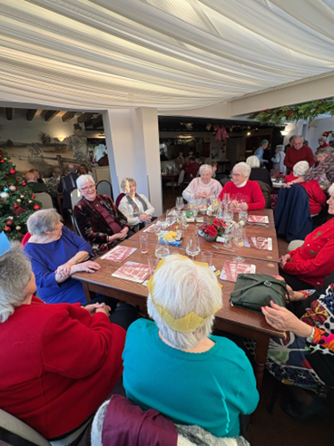





**Do you like working with primary children?**

**Enjoy crafts, baking, gardening, or all three?**

We're looking for extra volunteers for our weekly after-school club at Orleton Primary, doing an hour of activities with KS1 children on Mondays at 3.05pm.

It's a flexible commitment of as many weeks of the term as you want. DBS undertaken by the school.

Please contact Ian Mackay on

07736 303297 or [i.g.f.mackay@gmail.com](mailto:i.g.f.mackay@gmail.com) if you are interested



**Stars & Angels 2025**

Stars & Angels returned to St George’s, working in collaboration with the Village Hall and the Rec, on Saturday 6th December. It started in style with Santa and his elf being driven through the village in their sleigh, pulled by a tractor. The village groups providing displays had absolutely out-done themselves this year, with spectacular displays – if you haven’t had chance to view them yet, most of them will be up until 6th January. The craft tables were very popular, and the festive refreshments delicious. Thank you very much to everyone who helped make this such a wonderful occasion

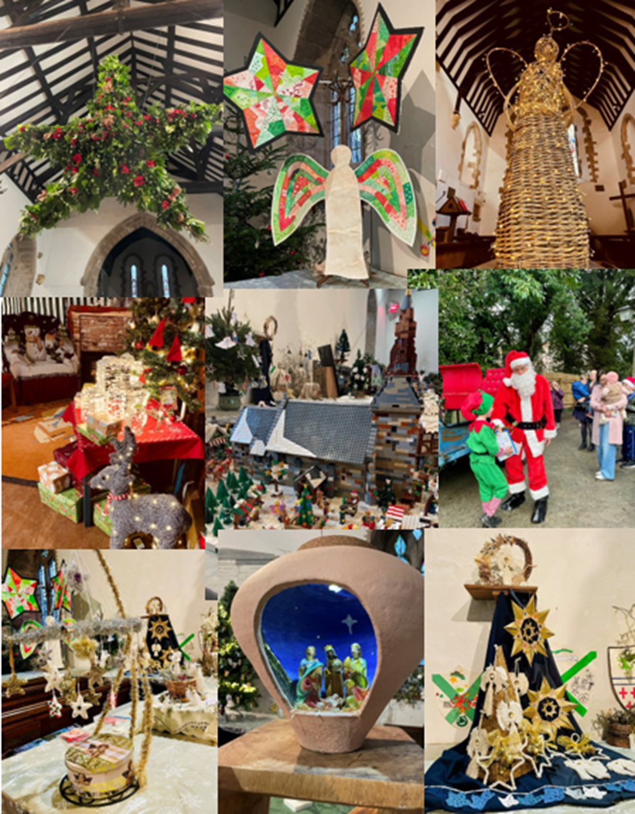



**Orleton WI**

Orleton W.I. would like to wish you all a Happy and Healthy 2026.

As we start a New Year many of us plan to take up a new hobby or interest. If you have never been to a W.I. Meeting why not consider joining us at the Village Hall on Monday 12th January at 2.30p.m.

Our meetings are held on the second Monday of the month with the exception of July and August.

Throughout the year we have Professional Speakers , Home Grown Crafts and talks from willing members an Outing usually in July, Strawberry Cream in August and a Christmas Bring and Share.

Our January meeting will be a Fun afternoon ‘trying our hand’ at Decoupage . The demonstration will be run by Sue (our President). All necessary items will be provided you would just need to bring a Glass Jar to decorate.

Our Programme for 2026 begins in April and will be published both on Orleton Online Magazine and in The Grapevine.

For any further enquiries please contact – Sue Copson on 07754 612231 or 01568 780956

email - susancopson[934@gmail.com](mailto:934@gmail.com)



**Safer Neighbourhood Team**

Suspicious Activity.

You know your community, you know who is around and what is normal community activity, so you are the best people to identify things that just don't sit right. Like the unusual pickup truck at old Mrs. Miggins' house, or the empty van that has parked in the gateway to the local farmer's yard/barn. Now there might be a perfectly reasonable explanation of why those vehicles are there, how would you ever know? We are certainly not expecting you to get involved, however what you could do, is take as much detail as possible: the registration plates, description of the people if you see them, anything that stands out for you, (amber light on the roof, ladders in the back) and just let us know. It is difficult for us to investigate a report of a 'suspicious white van' without any specific details.

You can do that via 101 (24 non-emergency police number), so this is if you think a crime or a concern is taking place right now, or if you just wanted to let us know how odd you thought it was, you can submit an online enquiry form on our website www.westmercia.police.uk,

or at our team email address

leominster.snt@westmercia.police.uk



**Orleton Charity Quiz Nights**

**Teams of up to six members. 7.30 for a 8.00pm start**

**Pre-booking of tables at:**

**the Boot (01568 780228) and the Maidenhead (01584 831686)**

**is strongly advised**

**All proceeds go to support local organisations in Orleton Village or**

**recognised National Charities.**

**Special Event: John Robbins Memorial Quiz at Orleton Village Hall**

**on a Saturday evening. Watch for the date!**

January 13th Maidenhead

February 10th Boot Inn

March 10th Village Hall

April 14th Maidenhead

May 12th Boot Inn

June 9th Village Hall





**Report from your County Councillor**

**Dan Hurcomb**

The volume of activity that goes on in Orleton is a credit to everyone who makes it happen, and I would also like to say thank you to those tireless volunteers behind the scenes who make it all happen.

Christmas is meant to be a time of goodwill to all however, I must report that the Government have not recognised this in the publication of the draft Local Government Financial Settlement (this is the route via which Herefordshire Council gets its central funding). The figures are slightly worse than we feared and whilst we are still working through the exact details, it is clear that the deficit between what we need and what we are allocated will be over £27 million. The settlement is in place for three years and it shows decreasing funding from the centre in each of those three years. The Government has even included a yearly council tax increase of 4.99% in their figures. Whilst I am sorry to be the bearer of bad news, it is important that every resident knows the context of the decisions that need to be made in the new year, As always, I will be looking to protect the services that matter most to rural residents and if you would like to raise any of these with me then please do email or call.

In happier news, I was delighted to be asked to read a lesson at the Nine Lessons and Carols service in Yarpole Parish. This was held at the historic St Michaels and All Angels Church at Croft Castle. Whether you are religious or not, carol services represent a chance for communities to come together at this important time of the year, and I try to attend as many as I can where the diary allows.

2025 has been a pivotal year for our highways locally. We have seen a huge volume of road resurfacing works across Bircher Ward, and I hope that you have noticed the difference. The improvements to the B4362 at Comberton and Yarpole and the B4361 at Richards Castle and Luston were particular highlights. Alongside this we had the complete resurfacing of the Kings Road / Kitchen Hill Road in Orleton with accompanying traffic calming measures. Despite all of this work, I am conscious that many residents who live down C or U classification roads have areas that require resurfacing or patching works, and I will be pushing the council to invest in these next year.

As always if you have any concerns, issues or would just like to chat then please do get in touch. Finally, I would like to say thank you to all of you who have taken the time to write, call or just have a chat with me at an event or in one of the pubs. It is this contact that makes the job worth doing!

Let me take this opportunity to wish you all a very Merry Christmas and a Happy New Year.

Dan Hurcomb

dan.hurcomb@herefordshire.gov.uk

07837726821

Open the Book 

Could you be a storyteller?

OtB is an exciting storytelling project where a group of people share Bible stories with the children in Orleton school on a Tuesday morning each fortnight. The stories are interactive and the children love to help deliver the 10–15-minute scripted Bible stories as part of Collective Worship.

We are currently a small team made up of trained and safely recruited volunteers from our local churches and organisations who follow the Bible Society Open the Book Code of Practice.

A Bible story well told has the power to spark imagination, inspire exploration, give hope, create a smile, teach important lessons and connect generations.

We would love to hear from you if you feel you could join our group.

The children and staff make us SO welcome! Please contact the school directly.

01568 780366 or email at: [admin@orleton.hereford.sch.uk](mailto:admin@orleton.hereford.sch.uk)

Thank You.

.



Orleton History Group

Our celebration of 900 Years of St George’s concluded with an event hosted jointly by the St George’s Community Association and the Orleton History Group: a taste of mince pies and wines made from recipes from over the past 900 years. Great fun was had by all!

Our upcoming talks & events are below. The talks are all free, donations invited for refreshments & heating:

**Saturday 24th January, 2.30pm,**

**St George’s Church:**

**Bitten by Pigs and Struck by Lightning: How Coroners' Rolls can Expand our Knowledge of Life in the Late Middle Ages'.**

Janine Bryant will lead us through this fascinating history. The role of the coroner was introduced in England in 1194, and it was his role to investigate all deaths that occurred in unusual or suspicious circumstances, as well as any deaths that occurred in prison.

These investigations or 'inquests' were recorded, and a considerable number still survive. The description of each death provides a snapshot of how people were living at that time, offering

a rare insight into life in the Late Middle Ages.

**Saturday 28th February at 2.30pm,**

**St George’s Church:**

**“Bongs in the Belfry": How St George's bell keeps us on time, hour by hour.**

Terry Tandler, with Len Vidler, will tell us the fascinating story of St George’s bells.

**Saturday 28th March, 2.30pm,**

**St George’s Church:**

**An overview of St George’s Church history**

John Berry and Liz Mackay lead us through an overview of the twists and turns of the history of St George’s Church, looking at how the architecture, religious, social and political contexts changed.

You can also read reports on previous talks at the history group page at: [www.stgeorgesorleton.org.uk](http://www.stgeorgesorleton.org.uk) (and then click on ‘Orleton History Group’).

If you would like further information about the group, please contact Liz Mackay on  [e.e.mackay@gmail.com](mailto:%09e.e.mackay@gmail.com),

or 07484 679671

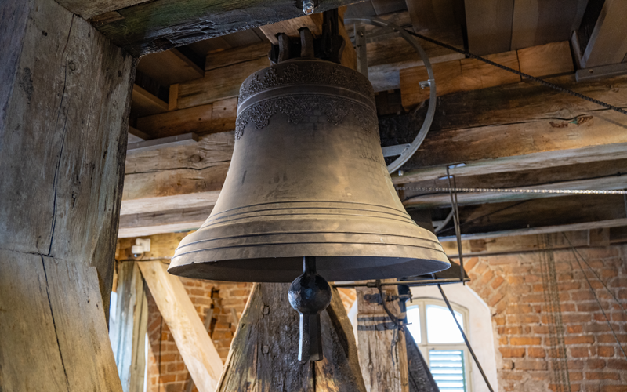

.

|  |
| --- |
| Image result for simple dove drawing  **Victoria Allen Funeral Services**  **(Est 2006)**  **An Independent Family Business**  **Private Chapel of Rest**  **Pre-Paid and Pre-Arranged Funeral Plans**  **Covering All Areas**  **Home Visits Always Available**  **24 Hour Service**  **Victoria Allen**  **8 Charlton Rise, Ludlow, Shropshire, SY8 1ND**  **01584 879035**  **Graham Bradley**  **6 Orchard Close, Kingsland, HR6 9QS**  **01568 708022**  **Email: vafs@btinternet.com**  [**www.vallenfuneralsludlow.co.uk**](http://www.vallenfuneralsludlow.co.uk)  SAIF (@NationalSAIF) | TwitterPrepaid Funerals – IC & SM Davies Llandovery Funeral Directors |



Orleton Young Farmer’s Club

Orleton YFC is delighted to announce the outstanding success of the Christmas Light Up Tractor Run 2025, which saw our biggest run to date with an incredible 99 vehicles lighting up the local area with festive cheer.

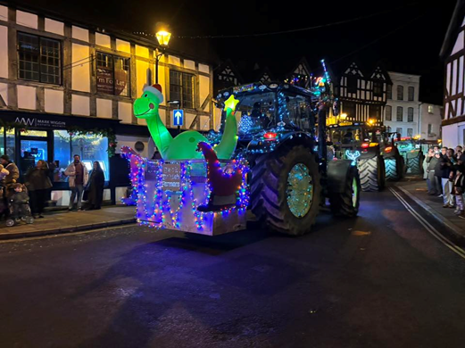

The spectacular tractor run, which started at McCartneys Livestock Market, featured beautifully decorated tractors and the much-loved Santa’s Sleigh, creating a magical Christmas atmosphere for everyone who came out to watch and support.

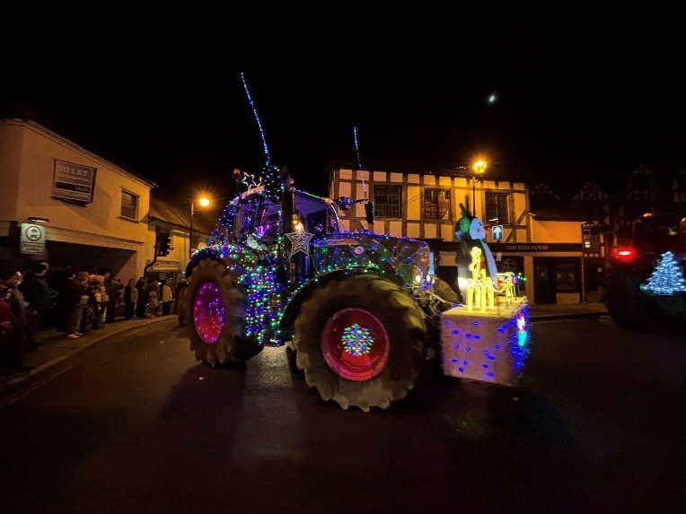

Firstly, we would like to say a huge thank you to everyone who took part, along with all the stewards, helpers, and

supporters who made the event possible. The effort and enthusiasm from everyone involved was truly amazing.

We are extremely proud to announce that the event raised a grand total of £2,066.

Thanks to this generosity, Orleton YFC will be donating:

* **£1,000 to the League of Friends of Ludlow Community Hospital**
* **£1,000 to Acorns Children’s Hospice**

Both charities do incredible work in our community and beyond, and we are thrilled to be able to support them through this event.

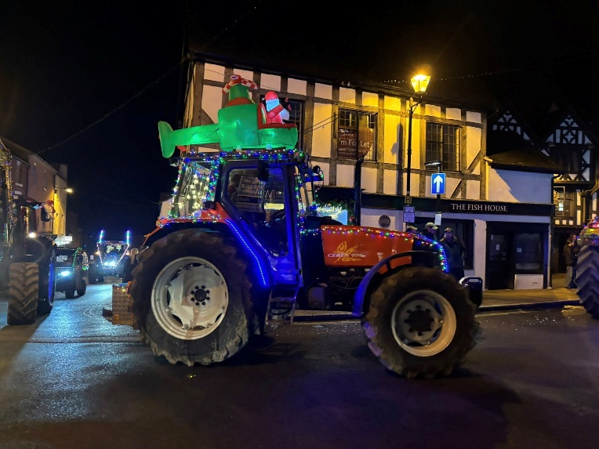

On behalf of everyone at Orleton YFC, we would like to wish you all a very Merry Christmas and thank you once again for your continued support.

We look forward to seeing you all again in 2026 for another Christmas Light Up Tractor Run

**ORLETON AND DISTRICT GARDENING CLUB**



**Wildlife Gardening**

On 25th November we welcomed Nancy Lowe, wildlife gardener and garden designer. Nancy divides gardens into three types – neat and organised, managed with some wild areas and wild gardens. Three essentials must be provided for wildlife to thrive, a year-round supply of food, water and winter shelter. The garden is a cyclical system, everything draws health from the soil and returns to the soil. The soil supports plants which provide food for insects which in turn feed herbivores which support top predators.

An annual mulch should be provided, ideally of garden compost which will be processed by invertebrates. Formal borders can play their part if spring flowers, primroses, pulmonaria and hellebores are planted in the bare areas beneath trees and shrubs and left to naturalise providing nectar for insects. Viburnum bodnantense and mahonia provide shelter and nectar in autumn through winter leaving open areas for summer flowers. Flowers with many florets, phlox and umbellifers for example will provide far more nectar and pollen than single flowers. Short growing plants for insects in lawns include prunella, speedwell, birds’ foot trefoil and white clover, the last two supporting common blue butterflies. Nancy advises planting plugs as seedlings may be overwhelmed by competing plants.

In wilder areas sun lovers include wild carrot, yarrow, ox-eye daisies and knapweed. Long grasses support Meadow brown butterflies, Gatekeepers and Skippers. Wood betony and columbine thrive in shadier areas. Teasels provide flowers for bees, seeds for goldfinches and shelter for hibernating insects.

Winter shelter can be provided by insect hotels, the crevices in trees and shrubs and piles of leaves, stone and wood. Tufty grasses, ferns and stems of veronicastrum, eryngium and poppy provide winter interest as well as shelter.

**One of the best ways to attract wildlife is to include a water feature. This provides somewhere for birds to drink and bathe and increases plant diversity by providing a habitat for submerged, emergent and floating plants. These support amphibians and insects such as dragonflies and mayflies.**

*Ghislaine Arundal*e

On Tuesday 29th January Tamsin Westhorpe of Stocktonbury Gardens, Leominster will present a talk entitled **‘Understanding the RHS Chelsea Flower Show Judging Process’**.

Tamsin is a RHS judge and speaker as well an editor of the English Garden Magazine.

At Orleton Village Hall.

**Doors open 7.15pm for 8pm start.**

**Non-members welcome at £2.50 per person which includes tea or coffee.**

**Annual Membership £15.0**

[**www.orletongardeningclub.co.uk**](http://www.orletongardeningclub.co.uk)

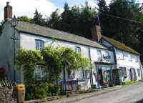

Orleton Village Shop

& Post Office

Shop Post Office

Mon- Fri 0745-1800 0745-1800

Sat 0830-1230 0830-1230

Sun 0830-1230 Closed

Changing buses or waiting for the 409?

Why not treat yourself to a Barista Coffee, Milk Shake or Smoothie?

Sample our range of delicious pastries and savories



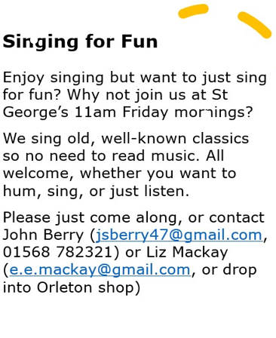







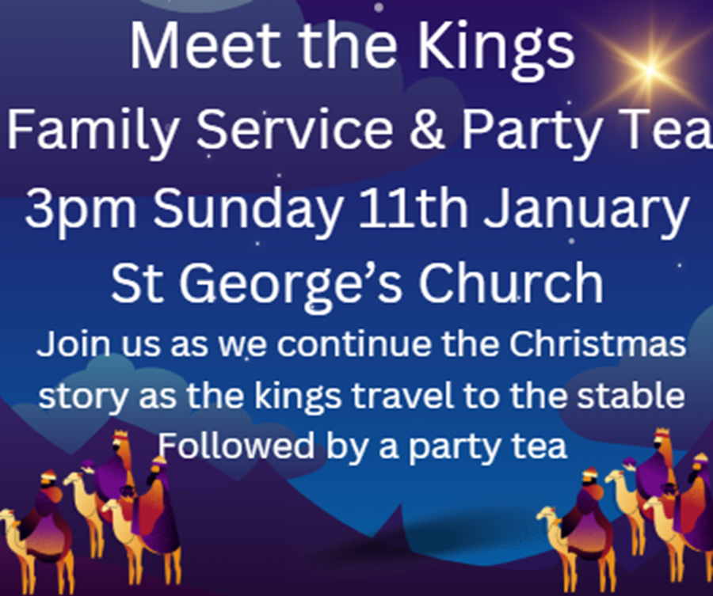

 **Orleton Craft Group**

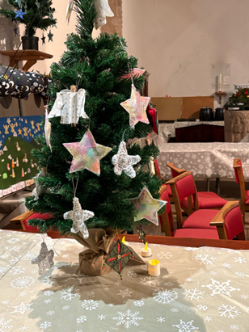

Wishing all our members (past, present and future!) a happy and healthy 2026.

Our first meeting in January is on Thursday 8th, 1:30 to 4:30 or any time in between, at Orleton Village Small Hall.

Bring along any craft you are working on and enjoy a chat, tea and cake!

Sue & Diane

Further information contact: [sue.a.turner@gmail.com](mailto:sue.a.turner@gmail.com) 07840 023856

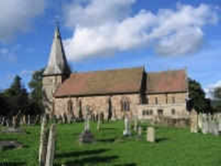Orleton Church & Chapel News

By the time you read this, Christmas will have been well and truly celebrated.

It kicked off with some lovely social events. Stars & Angels returned to St George’s, working in collaboration with the Village Hall and the Rec Association, on Saturday 6th December. It started in style with Santa and his elf being driven through the village in their sleigh, pulled by a tractor. The village groups providing displays had absolutely out-done themselves this year, with spectacular displays – if you haven’t had chance to view them yet, most of them will be up until 6th January. The craft tables were very popular, and the festive refreshments delicious. Thank you very much to everyone who helped make this such a wonderful occasion.

On 13th December, the St George’s Community Association hosted the final event of our 900 Years Celebrations, with a taste of mince pies and wines made from recipes from over the past 900 years. Great fun was had by all!

There was also a good range of services to celebrate Christmas, with a Christingle Service on Sunday 14th December; the school carol service on 15th December, the school end-of-term service on 17th December; carol singing at the Boot on Thursday 18th; a Carols by Candlelight service on Sunday 21st; a Crib Service and a Midnight Mass/Communion on Christmas Eve, and an informal Christmas Celebration on Christmas morning. There is even one last service to go – Meet the Kings on Sunday 11th January.

At the time of writing, none of this has happened yet, so fingers firmly crossed it all goes well!

Updates on our other activities, including an update on our Family Services, the Orleton History Group, Singing for Fun, Open the Book, food bank donations, and the 100 Club winners, can be found in our full newsletter, at: <https://stgeorgesorleton.org.uk/news/news> , and click on ‘Church & Chapel News’.

January 2026 Services & Times at St George’s & Chapel

Prayer meetings resume at Chapel on Wednesday 14th and 28th January 2026 at 4.30pm. All are welcome to join us for half an hour of quiet prayer.

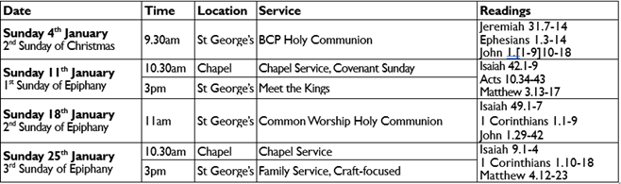

Further information

For further information about Church, Chapel, services or activities, or if you would like to get

involved either socially or as a member of the congregation then please contact:

Matthew Burns (Vicar, St George’s):

01568 614399,

teamvicarwest@leominsterteam.org.uk

Rev Denise Hargreaves (Methodist Minister): 01584 318628, [dkah26@gmail.com](mailto:dkah26@gmail.com),

Ludlow Church Office

01584 879233

Also, why not check out the St George’s website: https://stgeorgesorleton.org.uk.



Orleton Good Neighbour Scheme

The Good Neighbour Scheme supports our community using a team of volunteers to help people who are experiencing difficulty in their own homes essentially, by just doing things that good neighbours do for each other.

Examples of how the scheme can help:

* Fetching prescriptions
* Occasional lifts to the surgery or hospital
* Shopping and running errands, such as posting a letter.
* Practical tasks around the home, such as changing a light bulb or hanging a picture

**Contact Number 07467 535503**

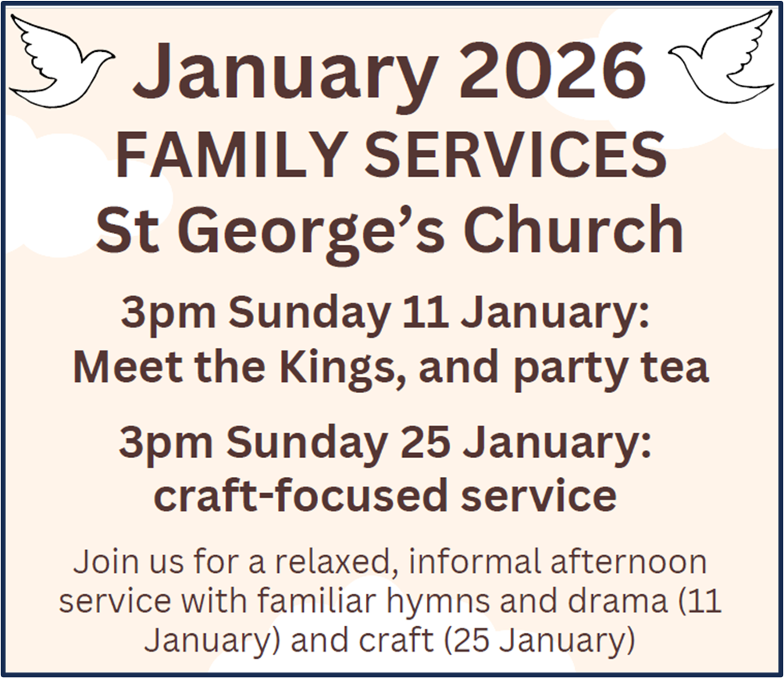

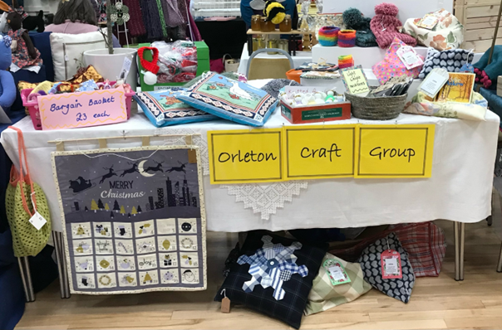

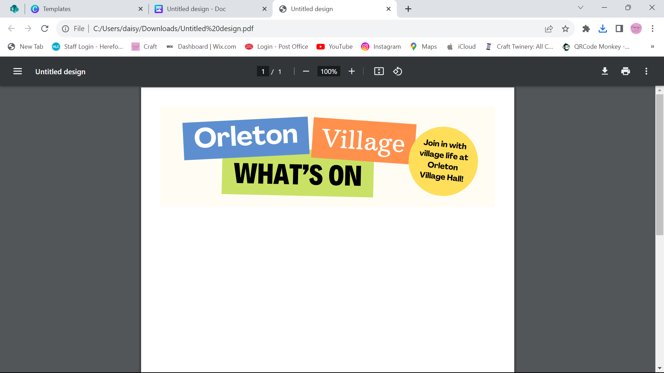

**Happy New Year from Orleton Village Hall**

**Dates for your diary…**

**Saturday 7th March** – Ludlow Concert Band return to the Village Hall

**The REGULARS Monday – Thursday …**

**Orleton Toddlers** Every Monday morning 10-11:45am

Contact: Bethan 07534 726222 or Charlotte 07964 981036

**Orleton WI** 2nd Monday of the month, October to March at 2:30pm

Contact: Sue Copson [susancopson934@gmail.com](mailto:susancopson934@gmail.com)

**Tai Chi** Every Tuesday 10:15-11:15am Contact: Rose Jacks jacks3@btinternet.com

**Rainbows** Every Tuesday in term time 4:30-5:30pm

Contact Kaye Harrison [kayemharrison@yahoo.co.uk](mailto:kayemharrison@yahoo.co.uk)

**Gardening Club** Last Tuesday of the month 7:30-9:30pm

Contact: Monica 01568 613361 [orletongc@hotmail.co.uk](mailto:orletongc@hotmail.co.uk)

**Yoga** Every Tuesday evening 6:30-7:30pm (Commences again in September)

Contact Rosie 07834 851656

**Coffee Morning** Every Wednesday at 10:30am-12:00 (Closed in August)

Contact: Cathy Hardwick [cathy.hardwick@hotmail.co.uk](mailto:cathy.hardwick@hotmail.co.uk)

**Library**  Last Wednesday of the month at Coffee Morning 10:30-11:45am

Contact: Sue Rogers 01584 831514

**Sequence Dancing** 3rd Wednesday of the month – 2-3pm

Contact: Amy Whitby [amyelwynwhitby@gmail.com](mailto:amyelwynwhitby@gmail.com)

**Evergreens** Last Thursday of the month – 2-4pm

Contact: Sue Turner [sue.a.turner@gmail.com](mailto:sue.a.turner@gmail.com)

**Craft Group** 1st and 3rd Thursday of each month 1:30-4:30pm (No sessions in August)

Contact Sue Turner 01584 831324 [sue.a.turner@gmail.com](mailto:sue.a.turner@gmail.com)

**Table Tennis** Every Thursday at 7:30pm Contact: Geoff Lewin [geoffnlewin@gmail.com](mailto:geoffnlewin@gmail.com)

**Hall available for private bookings**

**Contact Barry Gandy 01568 780583 or** [**bookings@orletonvillage.co.uk**](mailto:bookings@orletonvillage.co.uk)

**To include your event or amend an entry in the Dairy,**

**Please Email** [**orletonhandmade@gmail.com**](mailto:orletonhandmade@gmail.com) **by the 12th of the month**

All entries are, as far as we know, correct at the time of going to print.

**Contacts**

|  |  |  |  |
| --- | --- | --- | --- |
| Adopt a Footpath Group | Martin Bradford | emimart@hotmail.com | 01568 780151 |
| Allotments Assoc | Nick Ford |  | 01584 875834 |
| Art Group | Geoff Trotter | Geoffrey.a.trotter@gmail.com |  |
| Caring for God’ Little Acre | Barbara Mark |  | 01568 780842 |
| Church Wardens | Liz Mackay  John Berry |  | 07484 679671  01568 780321 |
| Cubs | Lisa Davies |  | 01584 831356 |
| Doctors |  |  | 01584 831300 |
| Evergreens | Sue Turner |  | 01584 831324 |
| Gardening Club | Nick Russel |  | 01568 780678 |
| Good Neighbour Scheme |  |  | 07467 535503 |
| Herefordshire Councillor | Cllr. Dan Hurcomb | dan.hurcomb@herefordshire.gov.uk | 07792 882147 |
| Land Drainage Group | David Lane |  | 01568 78036 |
| Orleton Relief in Need | Barry Rogers |  | 01584 831514 |
| Orleton Junior Football Club | Mel Williams | cherry.brook@me.com | 07511 920515 |
| Orleton Toddlers | Bethan Jenkins | Bethan.I.edwards@hotmail.co.uk | 07534 726222 |
| Orleton Young Farmers Club | Bell Beaumont | orleyonyfc@hotmail.com |  |
| Parish Council |  | clerk@orleton-pc.gov.uk |  |
| Pre-School | Tara Morris |  | 01568 780143 |
| Primary School |  |  | 01568 780366 |
| Primary School PTA | Nicola Goodman | nicolagoodman1989@gmail.com |  |
| Rainbows | Carly Morgan |  | 07788 236628 |
| Recreation Association | Graham Shaw |  | 01568 780783 |
| Village Hall |  | bookings@orletonvillage.co.uk | 01568 780583 |
| WI | Sue Copson |  | 01568 780956 |